Community Contribution Guidelines
AMM's Simulated Strategies Hub™
Cryptotized Gameplay™
Version 1.0

Welcome!
Thank you for your interest in contributing to AMM's Simulated Strategies Hub™.
This project exists because roleplaying is more enjoyable when creative ideas are shared. Every contributor has the opportunity to help expand Cryptotized Gameplay™ into new adventures, mechanics, and simulations while maintaining a consistent level of quality for the community.
Whether you're improving an existing guide or creating an entirely new campaign, your contributions are appreciated.

Our Mission
Our goal is simple:
Create immersive, strategy-driven roleplaying experiences that encourage creativity, critical thinking, and collaborative learning.
Every contribution should help players enjoy games in new and meaningful ways while respecting the original games and their creators.

Before You Submit
Please make sure your contribution:
✅ Is your original work.
✅ Is respectful toward other community members.
✅ Does not contain offensive, discriminatory, or illegal content.
✅ Does not encourage cheating in multiplayer games.
✅ Does not promote piracy or unauthorized game downloads.
✅ Does not violate another person's copyright or trademark.

Using the Official Template
Community guides should be created using the official Cryptotized Gameplay™ template whenever possible.
The template helps maintain:
- Consistent formatting
- Readability
- Organization
- Compatibility with future website features
You are encouraged to be creative, but the overall structure should remain recognizable.

What We're Looking For
We welcome submissions such as:
- New roleplaying campaigns
- Creative narratives
- Economic simulations
- Business systems
- Property systems
- Character progression ideas
- AI prompt improvements
- Balancing suggestions
- New gameplay mechanics
- Documentation improvements

Quality Standards
Every submission should strive to be:
- Easy to understand
- Well organized
- Original
- Accurate whenever possible
- Fun to play
- Tested before submission
If your guide relies on game mechanics, please verify that those mechanics exist in the supported version of the game.

Intellectual Property
By submitting content, you confirm that:
- You created the submission yourself, or you have permission to submit it.
- Your submission does not knowingly infringe another person's intellectual property rights.
If your submission is accepted, you grant AMM's Simulated Strategies Hub™ a non-exclusive, worldwide, royalty-free license to publish, display, edit, and distribute your contribution as part of the project.
This allows the project to include your work while you retain ownership of your original contribution.
You will be credited whenever reasonably possible.

Submissions
You can upload your guides through here, make sure to add “Roleplaying Guide Submission” as your subject.

Email: contact@ammstrategieshub.com

Review Process
Not every submission will be accepted.
Submissions may be declined if they:
- Do not fit the goals of the project.
- Duplicate an existing guide without offering meaningful improvements.
- Contain excessive AI hallucinations or inaccurate information.
- Are incomplete.
- Require major revisions.
- Violate these guidelines.
Declining a submission is not a judgment of the author's creativity—it's simply part of maintaining a consistent experience for the community.

Collaboration
Constructive feedback is encouraged.
Please:
- Be respectful.
- Explain your suggestions.
- Focus on improving ideas.
- Welcome different approaches to roleplaying.
Remember that everyone here is learning together.

AI Usage
AI-assisted writing is welcome.
However:
- Review AI-generated content before submitting it.
- Verify important facts.
- Make the guide your own.
Contributors remain responsible for the accuracy of their submissions.

Community Recognition
Outstanding contributors may be recognized through:
- Contributor credits
- Featured guides
- Community spotlights
- Website recognition
- Future community events

Our Philosophy
Cryptotized Gameplay™ is built on curiosity.
Experiment.
Share ideas.
Test mechanics.
Improve together.
There is no single "correct" way to roleplay.
The best ideas often come from collaboration.

Thank You
Whether you're submitting your first guide or your fiftieth, thank you for helping build this community.
Learn. Simulate. Improve.

# Find me on your favorite platforms #

Email: contact@ammstrategieshub.com

GitHub: https://github.com/AMMs-Simulated-Strategies-Hub

X-Twitter:
https://x.com/AMMsSimStrategy

Instagram:
https://www.instagram.com/ammssimulatedstrategieshub?igsh=MXEyYmhyZnpxYzRlZg==

The End

In the future, I hope my website and community will become the next GitHub for roleplaying research and development.

Thank you for participating, please feel free to leave feedback on my platforms!

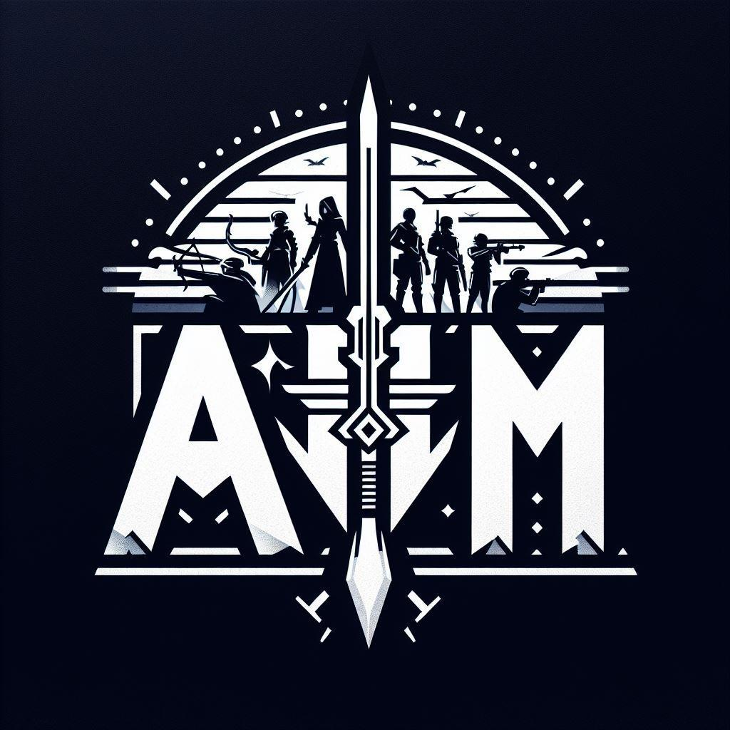

AMM's Simulated Strategies Hub™
Copyright © 2026 Angel Mendez. All Rights Reserved.

